Chapter 10, Solution 75.

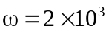
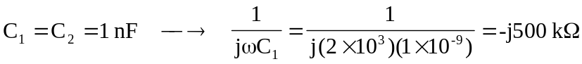

Consider the circuit shown below.
+
-
+
-
40 kW
100 kW
V₂
V₁
100 kW
V_{S}
20 kW
-j500 kW
+
V_{o}
-
-j500 kW
V_{b}

Let V_{s} = 10V.

At node 1,
[(V₁–10)/(–j500k)] + [(V₁–V_{o})/10⁵] + [(V₁–V₂)/(–j500k)] = 0
or (1+j0.4)V₁ – j0.2V₂ – V_{o} = j2 (1)

At node 2,
[(V₂–V₁)/(–j500k)] + [(V₂–0)/100k] + 0 = 0 or
–j0.2V₁ + (1+j0.2)V₂ = 0 or V₁ = [–(1+j0.2)/(–j0.2)]V₂
= (1–j5)V₂ (2)

At node b,
V_{b} = 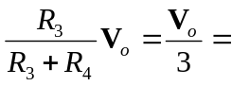 V₂ (3)

From (2) and (3),
V₁ = (0.3333–j1.6667)V_{o} (4)

Substituting (3) and (4) into (1),

(1+j0.4)(0.3333–j1.6667)V_{o} – j0.06667V_{o} – V_{o} = j2

(1+j0.4)(0.3333–j1.6667) = (1.077∠21.8˚)(1.6997∠–78.69˚)
= 1.8306∠–56.89˚ = 1–j1.5334

(1–1+j(–1.5334–0.06667))V_{o} = (–j1.6001)V_{o} = 1.6001∠–90˚

Therefore,
V_{o} = 2∠90˚/(1.6001∠–90˚) = 1.2499∠180˚

Since V_{s} = 10,

V_{o}/V_{s} = 0.12499∠180˚.

